UNCAN.eu : a European initiative to better understand cancer

Kick-off meeting for the Coordination and Support Action 4.UNCAN.eu

The Coordination and Support Action “4.UNCAN.eu” had its official kick-off on September 8-9 2022 with a public event hosted by Inserm at les Cordeliers, Paris, France.
4.UNCAN.eu CSA : Pave the way for UNCAN.eu initiative
An initiative to better UNderstand CANcer (UNCAN.eu) is part of the implementation roadmap of two programs of the European Union (EU), Europe’s Beating Cancer Plan and the Horizon Europe Mission on Cancer. The role of 4.UNCAN.eu CSA, funded by the European Union through Horizon Europe, is to prepare a blueprint for UNCAN.eu within the next 15 months.
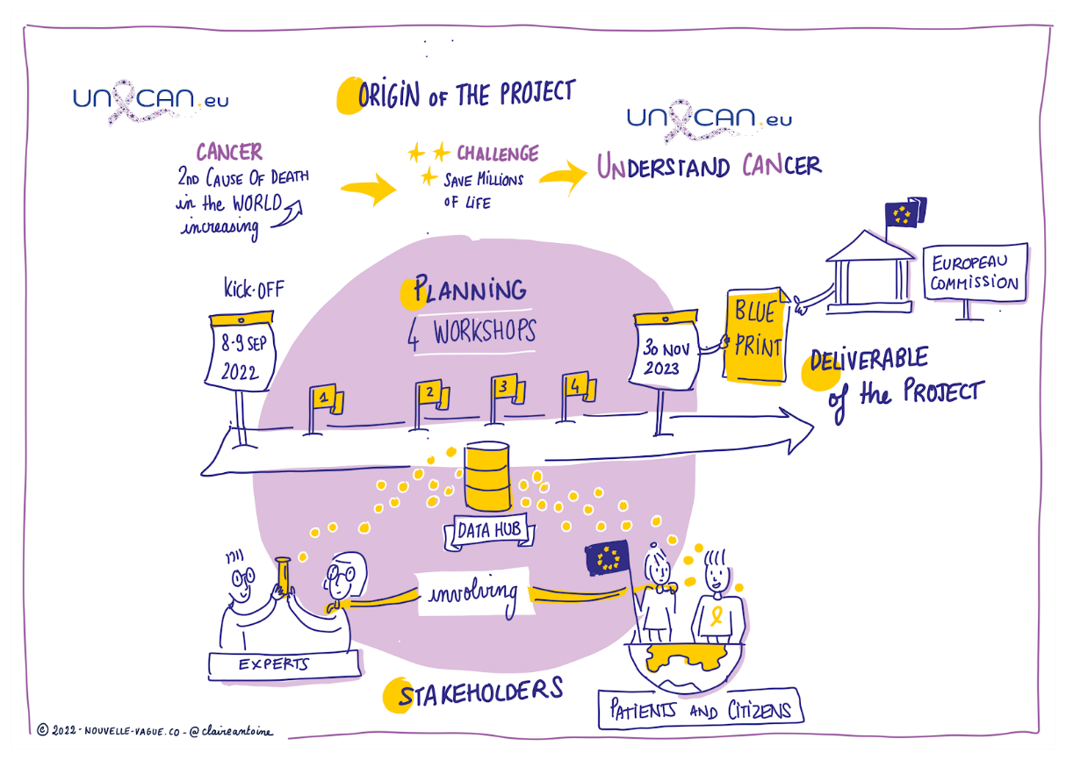
Credits : Claire Antoine / Nouvelle Vague

UNCAN.eu : an initiative to federate Member States against cancer
Across the 27 EU Member States, 2.7 million people are diagnosed with cancer every year and 1.3 million die from the disease. More than 6,000 disease victims are children, adolescents and young adults, cancer being the leading cause of child mortality from disease in Europe, and over half a million of European citizens are childhood cancer survivors dealing with long-term effects of the disease and its treatment. Cancer puts an immense pressure on health systems, which will only become stronger with increasing life expectancies.
A new level of investment to better understand cancer is needed to promote new thinking and hopefully new breakthroughs in our ability to prevent, diagnose and treat this disease. To this end, Europe calls for a strengthened collaboration among Member States to consolidate their stakes regarding data sciences to enable a leap forward in modern oncology and efficiently hinder the rise of disease burden.
The information, collected within UNCAN.eu, will be used by stakeholders in Europe and beyond to address the various urgent and critical scientific and medical challenges in cancer prevention, early diagnosis, treatment and survival, in men, women and children.
This initiative is expected to collect research and patient health data, as well other relevant data, at an unprecedented scale to gain new and deeper understanding of cancer mechanisms. The global ambition of this initiative is to further knowledge and guide improvements in cancer prevention, early diagnosis, and treatment, including treatment-related side effects. This will ultimately provide the basis to save millions of lives and improve the quality of life of cancer survivors and their caretakers.
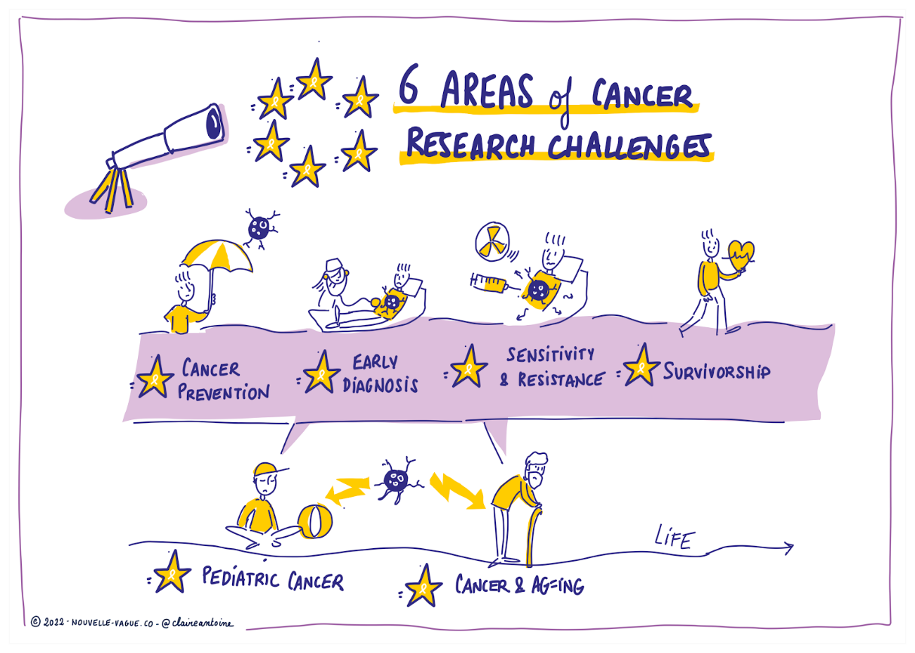
Credits : Claire Antoine / Nouvelle Vague
Two main missions: building a Federated Data Hub and providing a Research Agenda
The blueprint for UNCAN.eu will integrate inequalities in cancer research across regions and Member States to boost the research potential of less-developed regions in Europe. A dedicated workpackage, led by the ECPC (https://ecpc.org/health-and-research/4-uncan-eu/), will ensure that patients' and citizens’ expectations and priorities are heard and taken into account when identifying all challenges.
A Research Agenda including a series of use cases addressing urgent and essential scientific and medical needs in cancer prevention, early diagnosis, treatment and survivorship, in males and females of various ages will be delivered by the 4.UNCAN.eu teams. This agenda will then be used to help determine the most competitive, ambitious and innovative cross-border and transdisciplinary research programs to invest in.
Players will be committed to open science principles, including FAIR (Findable, Accessible, Interoperable, and Reusable) guiding principles for scientific data collection, management and stewardship.
The new understanding gained from the collection and analysis of this wealth of data can be applied secondarily to other diseases.
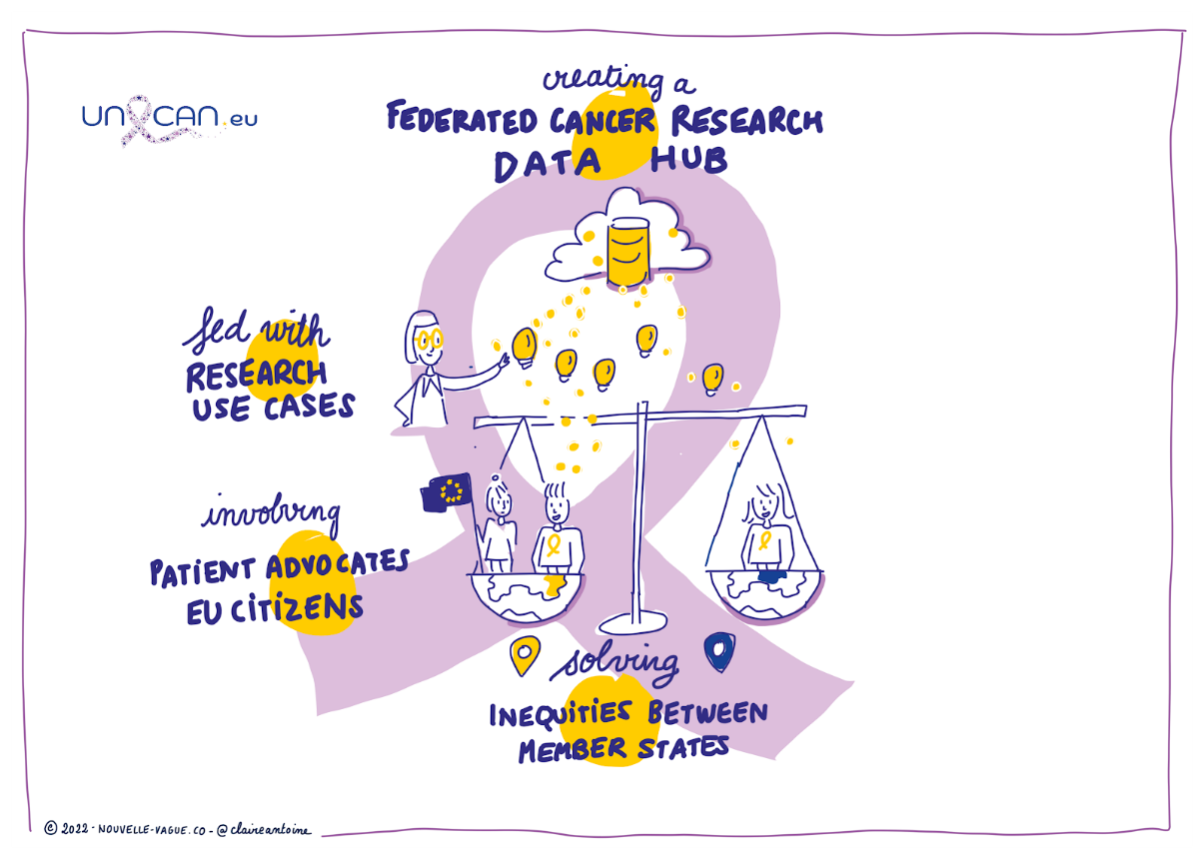
Credits : Claire Antoine / Nouvelle Vague
A committed European team towards a stronger European research :
The meeting was opened by Prof. Eric Solary of Inserm, who coordinates the project. An introduction to the EU Cancer Mission and Horizon Europe – EU cancer funded research followed by Mrs Christine Chomienne, Mission Cancer Board and Mr Ioannis Vouldis, UNCAN Project Officer, respectively.
Dedicated presentations from Charles Swanton, CRUK (Evolution, Metastasis and Immune Evasion: Insights from TRACERx); Jan Korbel, EMBL (Cancer Research data Hub); and Genevieve Almouzni, Curie Institute (LifeTime initiative), followed.
The representatives of the 29 institutions and organizations participating in the project have highlighted the importance of this scientific initiative, renewing their commitment and support toward the project while the main point of the meeting was the presentation of the activities that the partners will carry out during the 15 months of this project.

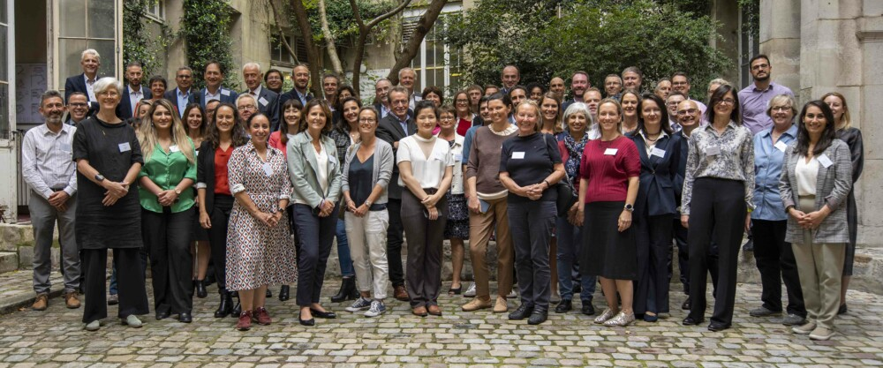
More information about 4.UNCAN.eu can be found at the Project’swebsite: http://uncaninitiative.eu/

Funded by the European Union. Views and opinions expressed are however those of the author(s) only and do not necessarily reflect those of the Health and Digital Executive Agency. Neither the European Union nor the granting authority can be held responsible for them.

